CHAPTER 3: Cells
Worksheet 3.8

Looking back
Answers
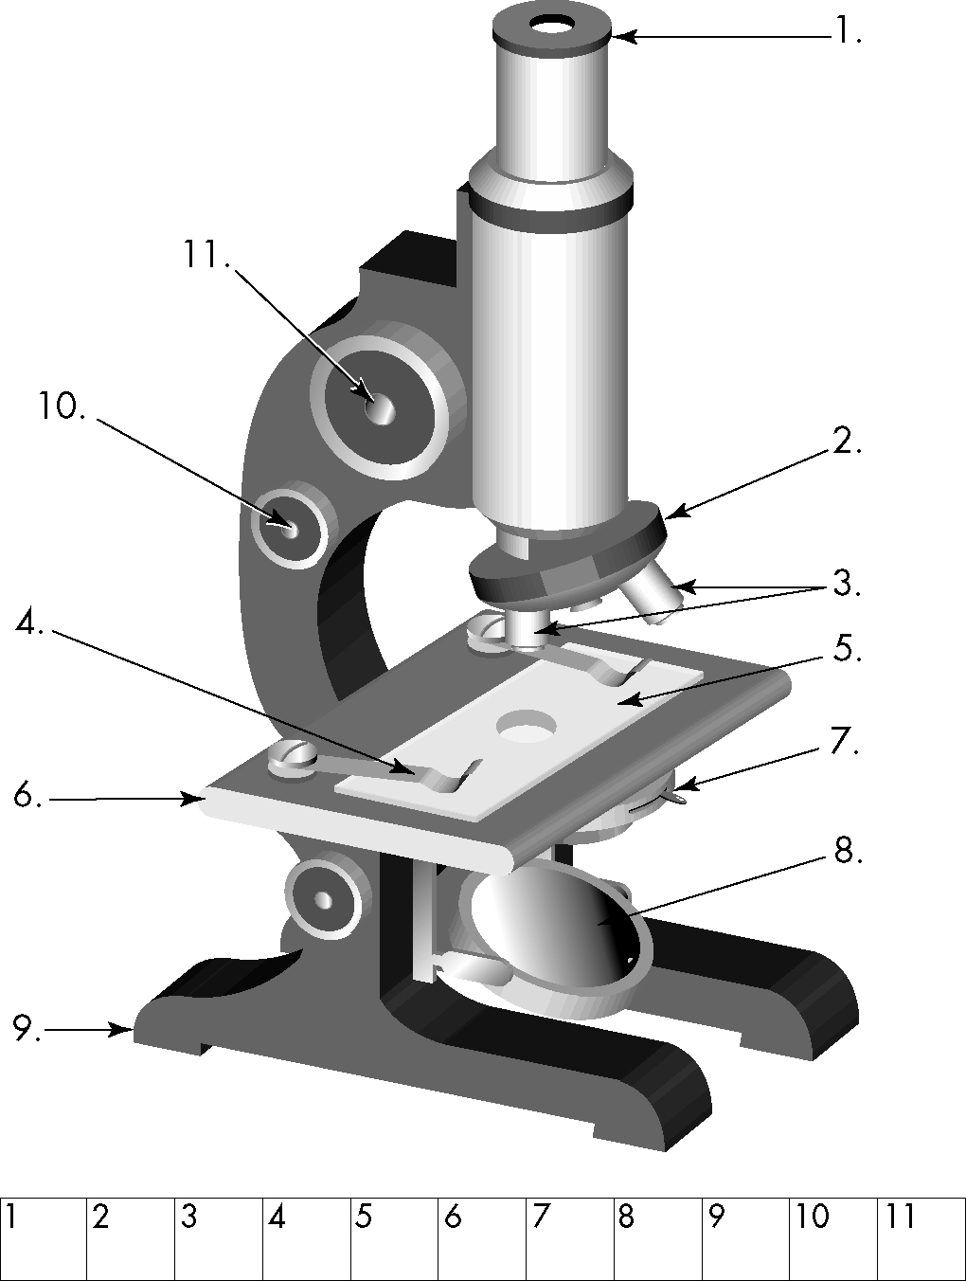
1. Complete the table below:
Cell feature | Plant cells | Animal cells
Cell wall |  | ❒
Cytoplasm
Cell membrane
Chloroplast |  | ❒
Nucleus
Large vacuole |  | ❒
2. What’s green and eats porridge? Identify the parts of the microscope on the right and use the code below to find out the answer to this riddle.
Code:
O = revolving nose piece; U = objective lenses;
S = coarse focus knob; K = fine focus knob;
D = microscope slide; L = stage slide clip; C = base; O = mirror; L = iris adjustment; I = stage;
M = eyepiece lens
3. Unscramble the words using the clues provided.
(a) Control centre of the cell SEUNCLU
MEMBRANE
NUCLEUS
M O U L D I L O C K S
(b) Surrounds the cell ERAMMBNE
VACUOLE
(c) Contains cell sap OCVAUEL
CYTOPLASM
(d) Part of the cell between the cell membrane and the nucleus CATOPLMYS
CELLS
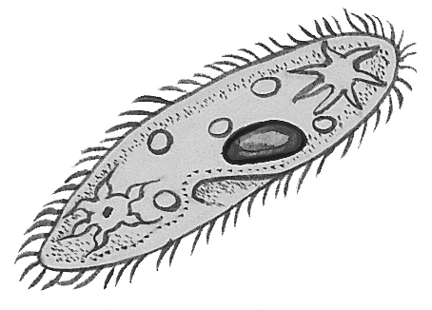
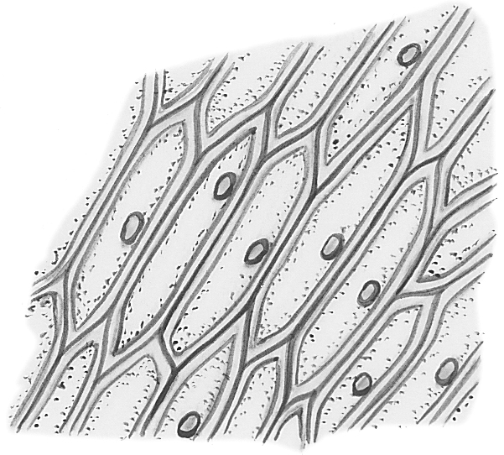
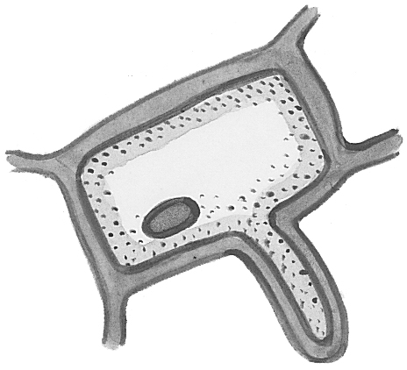
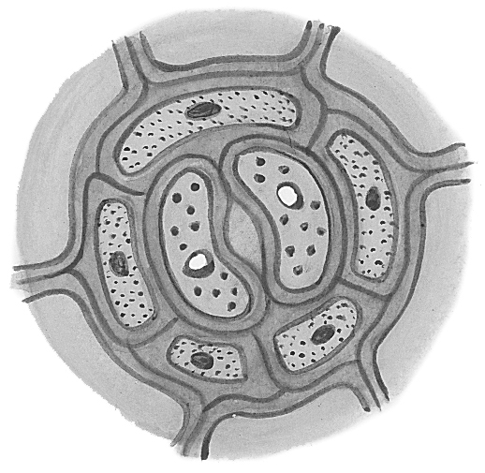
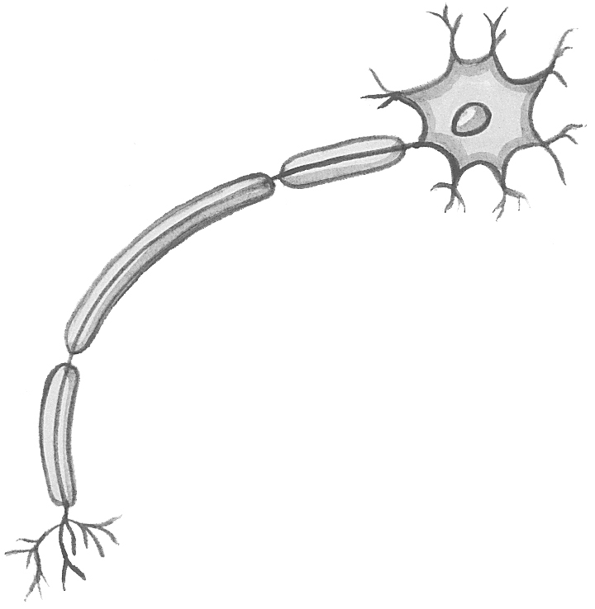
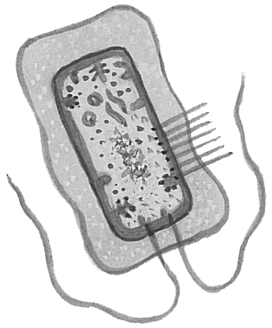
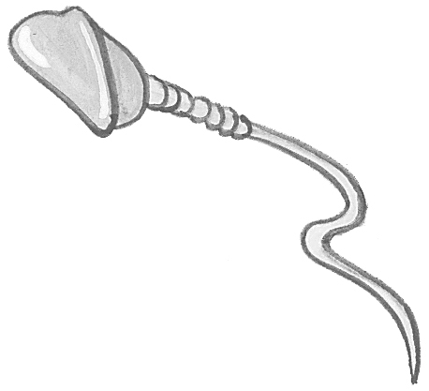
(e) Building blocks of all living things LELSC
ORGANISMS
a
c
b
d
e
f
g
h
(f) Living things ASMOGNIRS
4. Match the following cell names to the diagrams below right.
f Euglena
b Paramecium
h onion epidermal cell
e nerve cell
a sperm cell
c guard cells
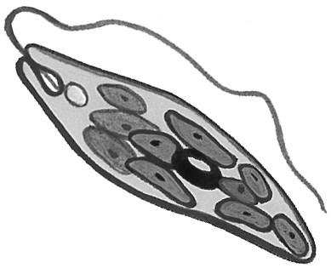
g root hair cell
d bacterium

